Report – Task 2
Exploratory Data Analysis (EDA)
Exploratory Data Analysis (EDA) is the process of examining and summarizing a dataset to understand its characteristics before performing advanced analysis or predictive modeling. This task focuses on identifying patterns, trends, distributions, and outliers within the provided sales dataset using Python and data visualization techniques.
Objectives
- To understand the structure of the dataset.
- To calculate descriptive statistics such as mean, median, and count.
- To identify customer purchasing trends.
- To detect potential outliers in numerical variables.
- To visualize important findings using charts.
- To summarize key insights obtained from the dataset.
Tools and Technologies
- Python 3.x
- Jupyter Notebook
- Pandas
- NumPy
- Matplotlib
Dataset Overview
The dataset contains sales transaction records with customer, product, payment, and pricing information.
Dataset Summary:
Total Records: 1200
Total Columns: 14
The dataset includes information such as:
- Order ID
- Order Date
- Customer Details
- Product
- Quantity
- Unit Price
- Total Price
- Payment Method
- Referral Source
- Order Status
Methodology
The following steps were performed during the analysis:
Step 1 – Import Libraries
Imported the required Python libraries for data analysis and visualization.
Step 2 – Load Dataset
Loaded the Excel dataset into a Pandas DataFrame.
Step 3 – Understand the Dataset
Examined the dataset structure using functions such as:
- head()
- info()
- shape
- columns
- describe()
Step 4 – Descriptive Statistics
Calculated statistical measures including:
- Count
- Mean
- Median
- Minimum
- Maximum
- Standard Deviation
Step 5 – Trend Analysis
Analyzed:
- Product popularity
- Payment method usage
- Referral sources
- Average revenue by product
Step 6 – Outlier Detection
Used the Interquartile Range (IQR) method to identify unusual values in the Total Price column.
Step 7 – Data Visualization
Created and saved the following charts:
- Product Distribution
- Payment Method Distribution
- Referral Source Distribution
- Average Revenue by Product
- Total Price Distribution
- Total Price Outlier Boxplot
Results and Findings
Product Analysis
The analysis showed that some products were purchased more frequently than others, indicating higher customer demand for those items.
Payment Method Analysis
Online payment methods were among the most commonly used, suggesting customers prefer digital payment options.
Referral Source Analysis
Different marketing channels contributed varying numbers of customers. One referral source generated noticeably more customer traffic than the others.
Revenue Analysis
Average revenue varied across products. Certain products generated significantly higher average sales values than others.
Outlier Analysis
A small number of transactions had unusually high Total Price values. These were identified as outliers using the IQR method. Such records may represent bulk purchases, premium products, or transactions that require further business investigation.
Visualizations
The following charts were generated and saved in the charts/ folder:
- product_distribution.png
- payment_distribution.png
- referral_sources.png
- revenue_by_product.png
- total_price_distribution.png
- outliers_boxplot.png
These visualizations helped identify customer behavior, purchasing patterns, revenue trends, and unusual observations.
Key Insights
- The dataset contains 1200 transaction records suitable for analysis.
- Customer purchasing behavior differs across product categories.
- Digital payment methods are widely used.
- Marketing referral sources have different levels of effectiveness.
- Revenue is not evenly distributed among products.
- A small number of high-value transactions were detected as outliers.
- Data visualization made it easier to identify trends and patterns.
Conclusion
This Exploratory Data Analysis successfully examined the sales dataset using descriptive statistics and visualization techniques. The project identified important customer purchasing patterns, payment preferences, referral effectiveness, revenue distribution, and outliers. These findings provide valuable business insights and establish a strong foundation for future predictive modeling and dashboard development.

Codes
!pip install matplotlib

#Import libraries
import pandas as pd
import numpy as np
import matplotlib.pyplot as plt

#Load Dataset
df = pd.read_excel("Cleaned Dataset.xlsx")

df.head()

OrderID | Date | CustomerID | Product | Quantity | UnitPrice | ShippingAddress | PaymentMethod | OrderStatus | TrackingNumber | ItemsInCart | CouponCode | ReferralSource | TotalPrice
0 | ORD200000 | 2023-01-04 | C72649 | Monitor | 5 | 570.62 | 928 Main St | Debit Card | Shipped | TRK37947903 | 7 | SAVE10 | Instagram | 2853.10
1 | ORD200001 | 2024-08-23 | C75739 | Phone | 2 | 151.35 | 823 Main St | Online | Shipped | TRK91186779 | 3 | SAVE10 | Referral | 302.70
2 | ORD200002 | 2024-02-27 | C81728 | Tablet | 5 | 550.68 | 512 Main St | Credit Card | Cancelled | TRK42903982 | 8 | FREESHIP | Email | 2753.40
3 | ORD200003 | 2023-10-15 | C33540 | Chair | 1 | 273.19 | 275 Main St | Debit Card | Returned | TRK62788070 | 5 | SAVE10 | Facebook | 273.19
4 | ORD200004 | 2025-05-08 | C81840 | Printer | 4 | 626.01 | 668 Main St | Online | Delivered | TRK29241424 | 8 | SAVE10 | Email | 2504.04

#Data structure
df.info()

# Column Non-Null Count Dtype
--- ------ -------------- -----
0 OrderID 1200 non-null object
1 Date 1200 non-null datetime64[ns]
2 CustomerID 1200 non-null object
3 Product 1200 non-null object
4 Quantity 1200 non-null int64
5 UnitPrice 1200 non-null float64
6 ShippingAddress 1200 non-null object
7 PaymentMethod 1200 non-null object
8 OrderStatus 1200 non-null object
9 TrackingNumber 1200 non-null object
10 ItemsInCart 1200 non-null int64
11 CouponCode 891 non-null object
12 ReferralSource 1200 non-null object
13 TotalPrice 1200 non-null float64
dtypes: datetime64[ns](1), float64(2), int64(2), object(9)
memory usage: 131.4+ KB

#View column names
print(df.columns)

Index(['OrderID', 'Date', 'CustomerID', 'Product', 'Quantity', 'UnitPrice',
'ShippingAddress', 'PaymentMethod', 'OrderStatus', 'TrackingNumber',
'ItemsInCart', 'CouponCode', 'ReferralSource', 'TotalPrice'],
dtype='object')

#Check Dataset Size
print("Rows:", df.shape[0])
print("Columns:", df.shape[1])

Rows: 1200
Columns: 14
#Descriptive statistics
df.describe()

 | Date | Quantity | UnitPrice | ItemsInCart | TotalPrice
count | 1200 | 1200.000000 | 1200.000000 | 1200.000000 | 1200.000000
mean | 2024-03-22 16:58:48 | 2.945833 | 356.412750 | 5.485000 | 1053.968300
min | 2023-01-01 00:00:00 | 1.000000 | 11.390000 | 1.000000 | 11.390000
25% | 2023-08-03 18:00:00 | 2.000000 | 186.062500 | 4.000000 | 410.520000
50% | 2024-03-23 00:00:00 | 3.000000 | 364.210000 | 5.000000 | 823.615000
75% | 2024-11-08 12:00:00 | 4.000000 | 521.570000 | 7.000000 | 1578.475000
max | 2025-06-30 00:00:00 | 5.000000 | 699.930000 | 10.000000 | 3456.400000
std | NaN | 1.407557 | 197.177146 | 2.281983 | 819.856558

#Calculate Mean
mean_quantity = df["Quantity"].mean()

print("Average Quantity:", mean_quantity)
Average Quantity: 2.9458333333333333
#Calculate Median
median_quantity = df["Quantity"].median()

print("Median Quantity:", median_quantity)
Median Quantity: 3.0
#Calculate Count
count_quantity = df["Quantity"].count()

print("Count:", count_quantity)
Count: 1200
#Create a Charts Folder
import os

os.makedirs("charts", exist_ok=True)

#Analyze Product Distribution
product_count = df["Product"].value_counts()

print(product_count)
Product
Printer 181
Tablet 179
Chair 178
Laptop 173
Desk 170
Monitor 163
Phone 156
Name: count, dtype: int64
#Visualize Product Distribution
plt.figure(figsize=(8,5))
product_count.plot(kind="bar")

plt.title("Orders by Product")
plt.xlabel("Product")
plt.ylabel("Number of Orders")

plt.tight_layout()

plt.savefig("charts/product_distribution.png")

plt.show()

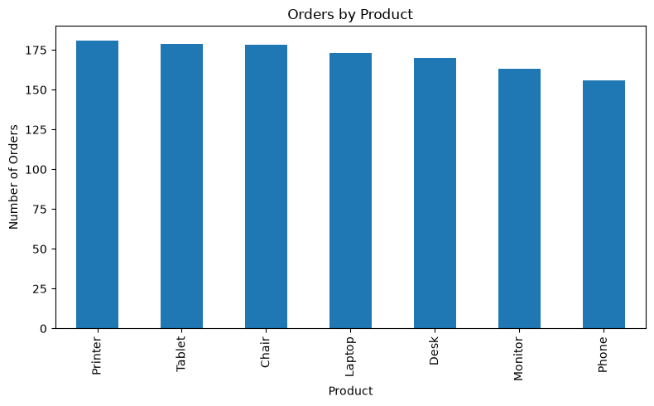
#Analyze Payment Methods
payment_count = df["PaymentMethod"].value_counts()

print(payment_count)

PaymentMethod
Online 258
Cash 246
Credit Card 234
Debit Card 232
Gift Card 230
Name: count, dtype: int64
#Visualize Payment Methods
plt.figure(figsize=(8,6))
payment_count.plot(
kind="pie",
autopct="%1.1f%%"
)

plt.title("Payment Method Distribution")
plt.ylabel("")

plt.savefig("charts/payment_distribution.png")

plt.show()

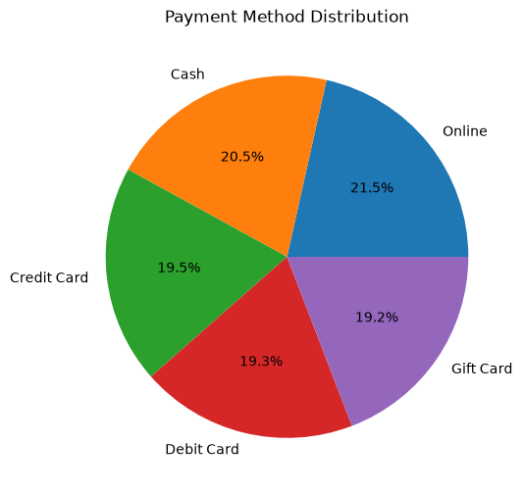
#Analyze Referral Sources
referrals = df["ReferralSource"].value_counts()

print(referrals)

ReferralSource
Instagram 259
Email 250
Google 241
Facebook 228
Referral 222
Name: count, dtype: int64
#Visualize Referral Sources
plt.figure(figsize=(8,5))
referrals.plot(kind="bar")

plt.title("Referral Sources")
plt.xlabel("Source")
plt.ylabel("Customers")

plt.tight_layout()

plt.savefig("charts/referral_sources.png")

plt.show()

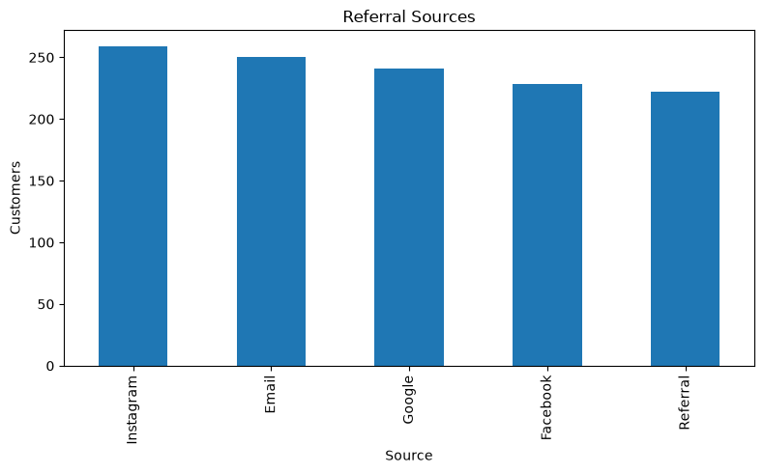
#Revenue Analysis
avg_revenue = df.groupby("Product")["TotalPrice"].mean()

print(avg_revenue)

Product
Chair 1098.989382
Desk 985.058412
Laptop 1110.558150
Monitor 1077.616012
Phone 972.579423
Printer 1080.732652
Tablet 1042.284637
Name: TotalPrice, dtype: float64
#Revenue Visualization
plt.figure(figsize=(8,5))
avg_revenue.plot(kind="bar")

plt.title("Average Revenue by Product")
plt.xlabel("Product")
plt.ylabel("Average Revenue")

plt.tight_layout()

plt.savefig("charts/revenue_by_product.png")

plt.show()

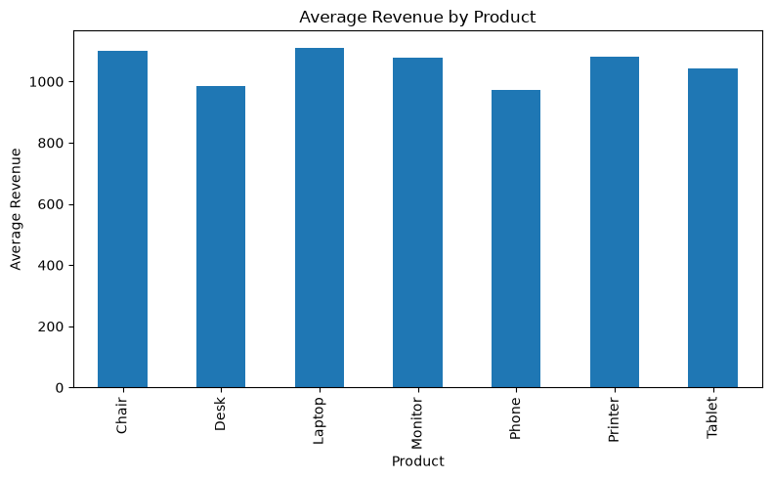
#Identify Outliers
Q1 = df["TotalPrice"].quantile(0.25)

Q3 = df["TotalPrice"].quantile(0.75)

IQR = Q3 - Q1

#Calculate Outlier Boundaries
lower_bound = Q1 - 1.5 * IQR

upper_bound = Q3 + 1.5 * IQR

#Extract Outliers
outliers = df[
(df["TotalPrice"] < lower_bound) |
(df["TotalPrice"] > upper_bound)
]

print(outliers)

OrderID Date CustomerID Product Quantity UnitPrice \
107 ORD200107 2023-03-27 C16775 Printer 5 670.75
326 ORD200326 2024-07-01 C65986 Laptop 5 670.48
328 ORD200328 2023-02-28 C18404 Tablet 5 674.04
469 ORD200469 2023-11-26 C13877 Chair 5 676.98
632 ORD200632 2023-05-02 C67260 Laptop 5 678.16
789 ORD200789 2023-08-17 C57276 Tablet 5 691.28
1065 ORD201065 2023-10-30 C47778 Printer 5 666.80
1122 ORD201122 2023-06-07 C38840 Monitor 5 678.19

ShippingAddress PaymentMethod OrderStatus TrackingNumber ItemsInCart \
107 848 Main St Gift Card Shipped TRK34392124 8
326 273 Main St Gift Card Returned TRK98353867 5
328 546 Main St Online Cancelled TRK89401624 7
469 893 Main St Cash Cancelled TRK17254691 5
632 463 Main St Gift Card Delivered TRK38229104 7
789 183 Main St Online Delivered TRK75899752 10
1065 488 Main St Debit Card Delivered TRK79504329 7
1122 766 Main St Online Returned TRK32496970 8

CouponCode ReferralSource TotalPrice
107 FREESHIP Instagram 3353.75
326 SAVE10 Facebook 3352.40
328 SAVE10 Google 3370.20
469 NaN Facebook 3384.90
632 WINTER15 Facebook 3390.80
789 SAVE10 Email 3456.40
1065 SAVE10 Referral 3334.00
1122 NaN Facebook 3390.95
#Count Outliers
print("Number of Outliers:", len(outliers))
Number of Outliers: 8
#Visualize Outliers
plt.figure(figsize=(8,5))

plt.boxplot(df["TotalPrice"])

plt.title("Total Price Outliers")
plt.ylabel("Total Price")

plt.savefig("charts/outliers_boxplot.png")

plt.show()
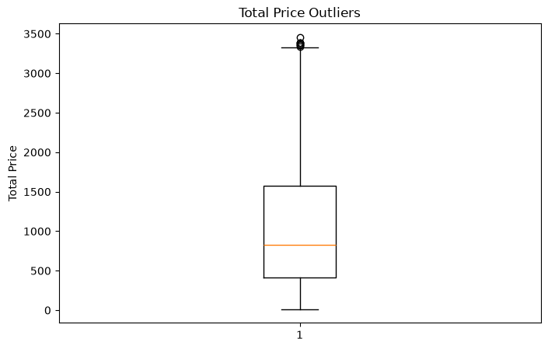

#Histogram of Total Price
plt.figure(figsize=(8,5))

plt.hist(df["TotalPrice"], bins=20)

plt.title("Total Price Distribution")
plt.xlabel("Total Price")
plt.ylabel("Frequency")

plt.tight_layout()

plt.savefig("charts/total_price_distribution.png")

plt.show()

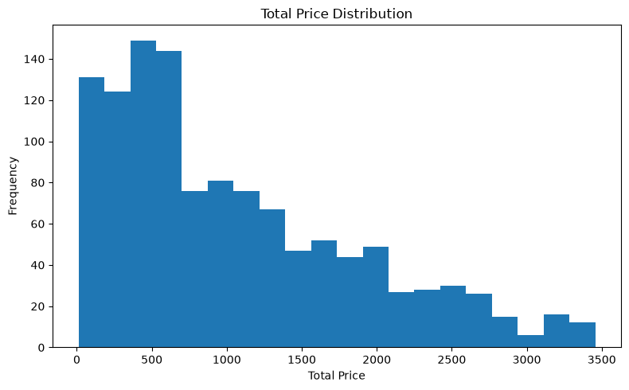
#Correlation Analysis
correlation = df[
["Quantity",
"UnitPrice",
"TotalPrice"]
].corr()

print(correlation)

Quantity UnitPrice TotalPrice
Quantity 1.000000 0.014553 0.615251
UnitPrice 0.014553 1.000000 0.717081
TotalPrice 0.615251 0.717081 1.000000

#Verify Saved Files
import os

print(os.listdir("charts"))

['outliers_boxplot.png', 'payment_distribution.png', 'product_distribution.png', 'referral_sources.png', 'revenue_by_product.png', 'total_price_distribution.png']

